Tweeting, Following and Retweeting on #Twitter...

Twitter is a great way to keep up with plenty of things and events going on around the world. Whether that’s the news, sport, running, celebrities or even HERC!

This guide should help you in terms of setting up and account and the basics of using twitter. It is essentially similar to Facebook but it is more of an informal arena for discussing and commenting on all things going on.

The club uses Twitter as well as Facebook. This is a publicly viewed area but one which includes plenty of support and encouragement as well as some good laughs and banter.

Creating an account

To begin with, just like Facebook, you need to create an account. You will need to create a username which you will be recognisable by as well as your email address and password which is specific to you.

When you come to logging in again, you can use either your email or your twitter username and then your password. Twitter is also available as an app on all smartphones, the same process can be undertaken to set it up for ease of access.

Home Page

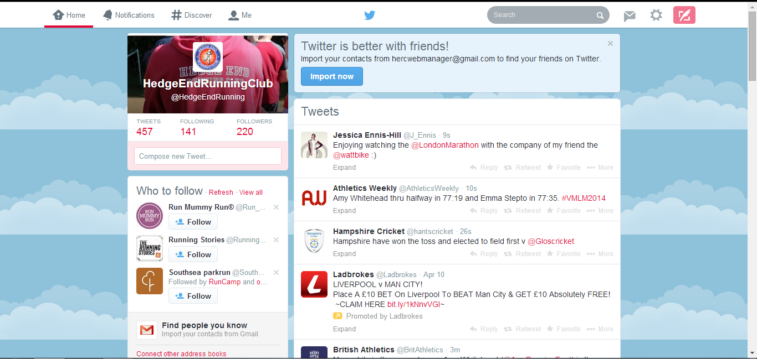
The homepage of twitter will be shown like above. There is a Home tab in the top left corner, followed by Notifications, Discover and Me. On the right there is the tab to create a tweet, the settings icon and the direct message tab. Finally is the search bar to search for other users and groups.

Following and Followers

This is essentially having friends on Twitter. You are able to follow other people to view what they wish to Tweet about and other people are able to follow you in order to read about your Tweet's.

Use the search bar at the top to find people you may find of interest. Also by clicking through peoples profiles you can find who they follow and who follows them which may be similar to you.

It is possible to make your profile private, which is found in the settings section, in order to make your account more secure and giving you more discretion on who you allow to follow.

HERC's username is @HedgeEndrunning to follow us simply search for our name and hit follow!

Creating a Tweet - Tweeting

In the top right hand corner, there is the 'Compose new Tweet' tab. This allows you to write how you are feeling, what you have been up to or what run you've just been on! The difference to Facebook is you are limited to the 140 characters for your Tweet.

To mention people in a Tweet, you have to use an @ symbol. This allows you to link your tweets to people and groups. You are able to mention as many people as you like in a Tweet but remember you only have 140 characters.

It is possible to put pictures into tweets, just with Facebook there is a photo icon which you click on and upload onto the tweet.

HERC's username is @HedgeEndrunning

#Hashtags

When Tweeting, hashtags are used to help tweets fall into groups. Sports teams tend to use these a lot such as Southampton Football Club use #saintsfc and television shows will also such as Britain's Got Talent using #BGT.

Hashtags do not have to be just for Clubs or programmes but a common use is as an informal way such as describing how you're feeling #happy #tired #leadlegs or can be used for events such as Virgin London Marathon 2014 being #VLM14.

Hashtags are not essential for a tweet or actually needed but they do add to the light hearted approach that Twitter takes.

These are up for personal use and can vary in how serious they are to how jokey they can be also. Hashtags do tend to make a tweet quite funny so all aboard the hashtags! #HERClovehashtags

Receiving a Tweet

When somebody mentions you in a tweet you need to access the Notifications tab in the top left corner of the screen. This will highlight in bold with a number when you have been mentioned.

Here you can view what somebody has said to you and can then decide whether you wish to reply or not. Below the tweet will show you where you can reply to the tweet via a small arrow which has Reply.

Retweeting and Favourite Tweets

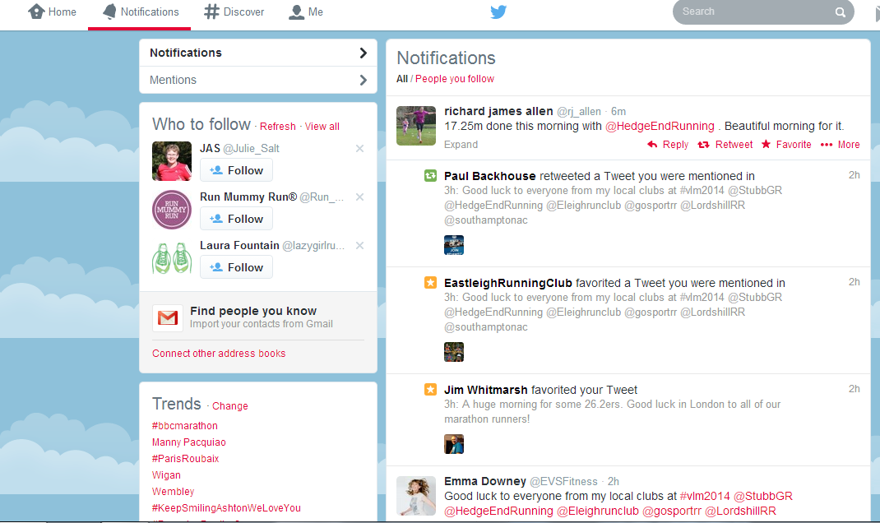
When people reply to a Tweet you made or mention you in one of their tweets, you can reply as mentioned earlier, but also you have two further options. RETWEETING and FAVOURITE.

To Favourite a Tweet, the small star symbol can be clicked. This is similar to 'liking' on Facebook and is a subtle way to inform the person who tweeted that you like their tweet.

Retweeting a Tweet is simply reposting the Tweet in order for people that follow you to see the post. The icon below which looks like two arrows together allows you to Retweet.

Extra Twitter Info

As with all social media accounts, be aware of what is posted and what you are posting as it can be viewed by anyone unless you restrict your account down on security settings.

You can update your personal information such as your small bio which gives a tiny insight into who you are and your interests as well as being able to update your profile picture.

You are able to direct message other Twitter users which is a way to communicate and message without anybody else seeing but you can only send them to people that are following you, this saves all of the celebrities getting thousands of direct messages.

We hope this guide has helped you slightly and inspired you to get on board with the new wave of Social Media.

If you need any more help or support on setting up, using or just what Twitter is even for please don't hesitate to contact one of the Social Media Team by contacting us via a private message on Facebook.

Happy Tweeting one and all, we look forward to seeing you on Twitter!! #redwhiteandblue

